Asian Hornet (Vespa velutina nigrithorax)
Summary
The Asian Hornet is a highly aggressive predator which poses a significant threat to honey bees and other pollinators in the UK. The Asian Hornet comes from south-east Asia. It was first confirmed in Europe in south-west France in 2004. The Asian Hornet established itself rapidly and is now throughout France and a number of European countries. The first UK sighting was in September 2016. Between 2016 and 2022 there have been 23 confirmed sightings in the UK including 14 nests. In 2023 there were 72 Asian Hornet nests found in 56 locations. All UK Asian Hornet nests located have been destroyed by DEFRA.
The UK strategy continues to be to eradicate newly arrived hornets.
The National Bee Unit (NBU), part of DEFRA, has provided an Asian Hornet Watch app and a reporting mechanism. Various public awareness strategies have been undertaken by the British Beekeeping Association (BBKA) and the NBU. There has been a lot of coverage in the national press on this non-native species of hornet. Unfortunately the lack of correct supporting material to assist the identification of the Asian Hornet by some in the national press has resulted in over 20000 reports in 2023 of which only 151 were confirmed as Asian hornets.
The BBKA have now introduced a traffic light zoning system with either selective traps or monitoring stations in place depending on the risk category of the zone concerned.

Proposal on how Burnham Town Council could assist
The Burnham area is currently categorised as a Green Zone. (Green Zone – Beyond 10km and where no hornets have been found in the previous year). The other side of the River Crouch will be in the Amber zone and Southend is Red as a nest was found there last year.
If possible we would like Burnham Council to agree to the siting of a Bait station on the wall next to the council garden. Bait stations do not trap Asian hornets or other insects, which can come and go as they please. The bait station will be a takeaway container with the lid on with a wick to draw up the bait which is insect friendly which will attract Asian Hornets.
Whilst I and other local beekeepers will attempt to visit this bait station daily if Council staff could also monitor that would be helpful. In the event of an Asian Hornet being seen a local beekeeper can come to take a photograph and report via the Asian Hornet Watch app.
I can provide credit card sized Asian Hornet ID cards and would be grateful if the Council could provide these to the Park rangers in case they spot hornets in the course of their patrols.

Appendix 1 – more detail on Asian Hornet in South- East England
In 2023, 76 nests have been located and destroyed in 56 locations, across 10 counties: Devon, Dorset, East Sussex, East Riding of Yorkshire, Essex, Greater London, Hampshire, Kent, North Yorkshire, and Surrey. The known distribution highlights that no area can become complacent regarding the threat of an Asian hornet incursion.
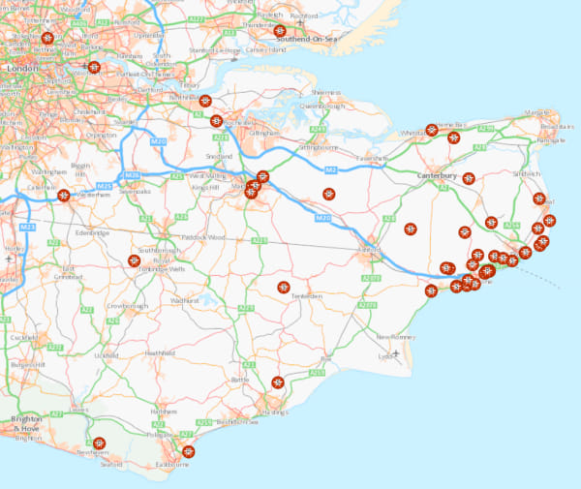

Map showing nest locations in south-east England as at 12/10/2023. All nests destroyed by DEFRA.
As a Beekeeper I am monitoring insects in the local area to monitor for Asian hornets without damaging native insect populations.
A recent study has calculated that a colony of Asian Hornets can consume 11.3kg of insects in a season. The same study also identified that if up to six one litre plastic bottle drowning traps deployed in the same area they can kill the same weight of insects over the same period. Hence it’s key that bait stations are used unless selective traps are deployed which are monitored daily and bycatch released.

I have provided a picture of an Asian hornet plus a description of both the Asian and European hornet.
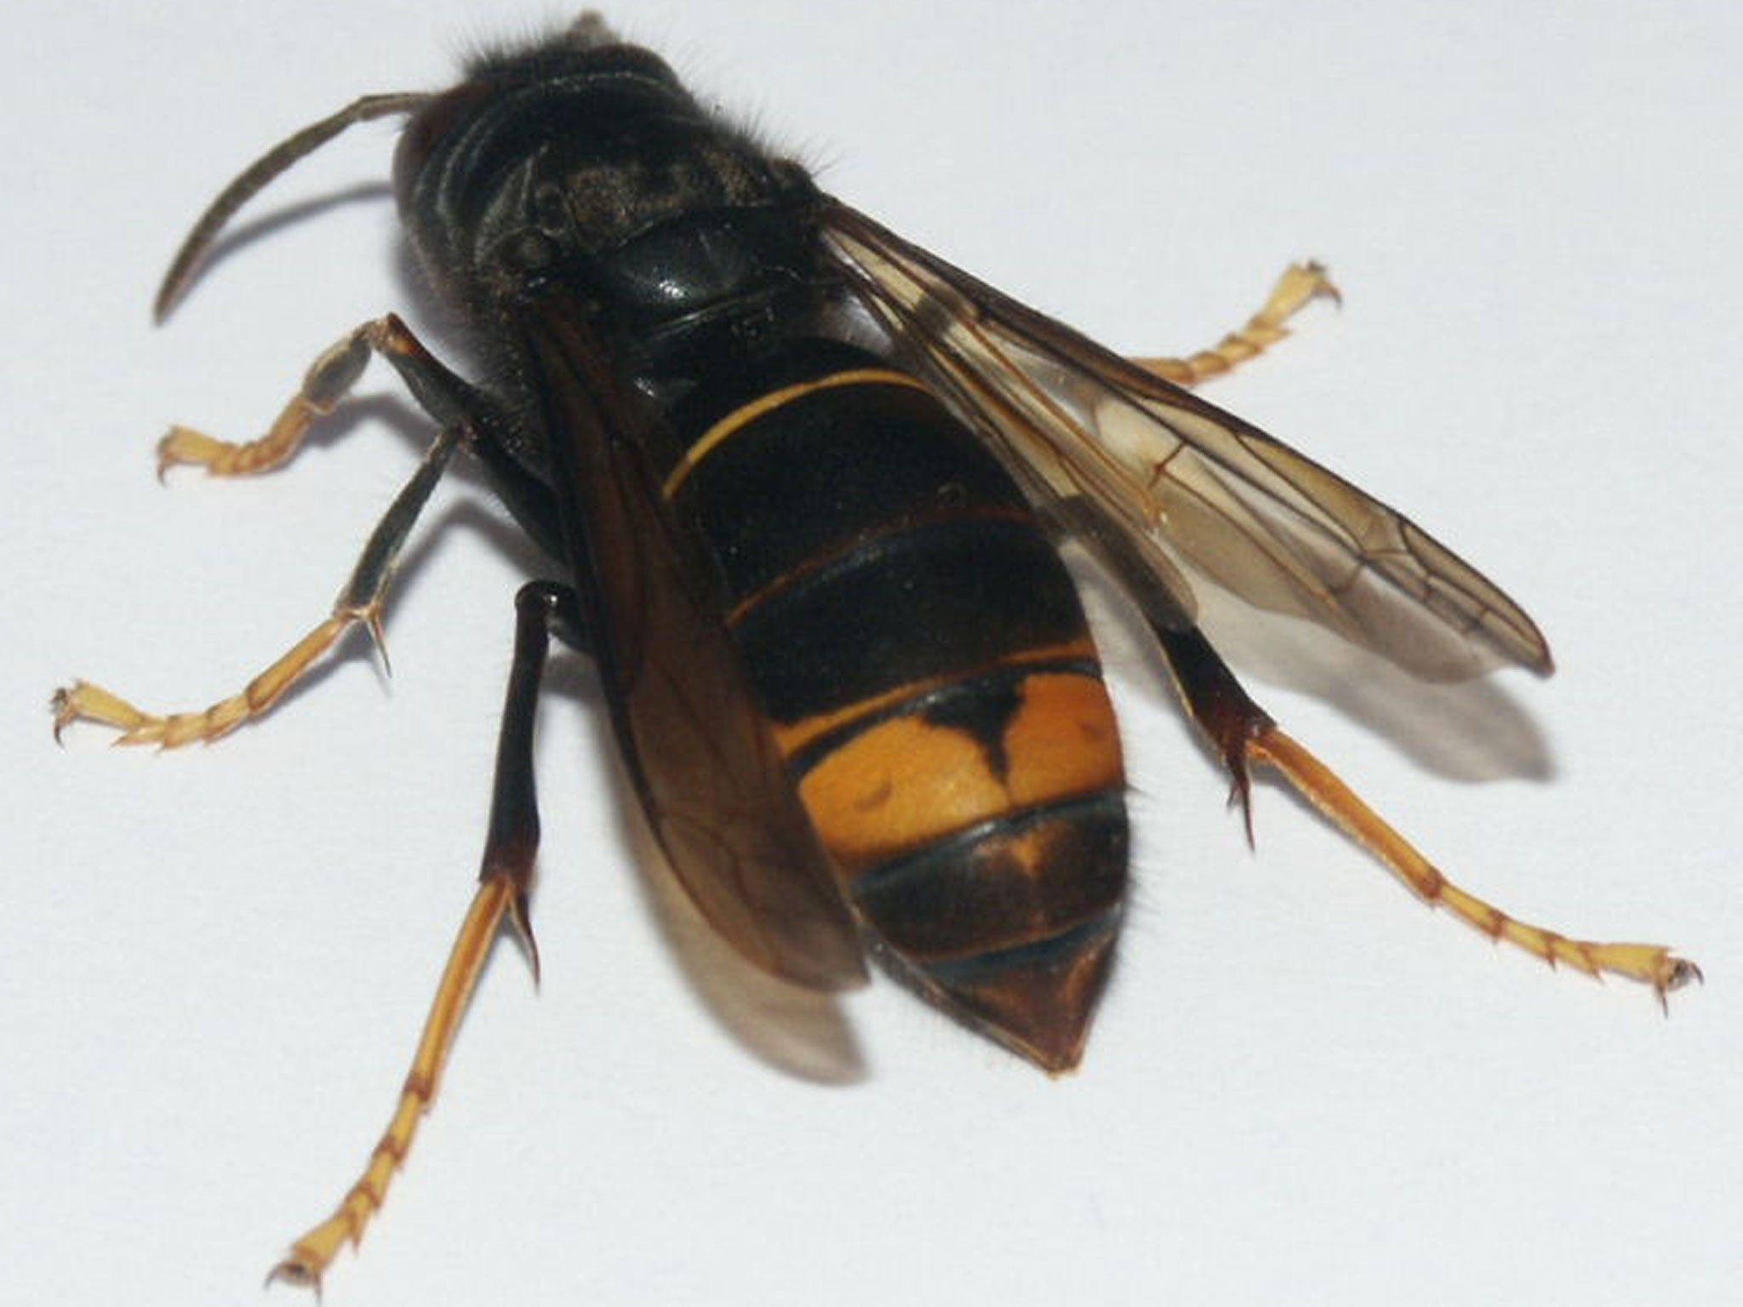
Asian Hornet
Asian and European hornets: comparison
Asian | European
- Queen is up to 30mm long | - Queen is up to 35mm long
- Worker is up to 25mm long | - Worker is up to 30 mm long
- Body is almost entirely dark brown or black except for the fourth abdominal segment which is yellow | - Thorax is black with extensive brown markings
- Legs are yellow at the ends | - Abdomen is yellow, marked with brown on the upper part
- Head is dark above, orange from the front | - Abdomen is not banded
- Antennae are dark | - Legs are brown at the ends
- Not active at night | - Head is yellow from above, yellow from the front
- Antennae are yellow
- Maybe active at night
Life cycle
- Founder queens emerge from hibernation (late January – March)
- Founder queen makes first ‘embryo’ nest (April – May) – builds nests high up in trees and man-made structures
- First brood of worker hornets emerges (April- May)
- Secondary nest construction and colony growth (May to September)
- Mature active nest (September – October) – forms colonies of up to 6000 insects
- Sexual adults emerge (Mid July – November) – a nest produces an average of 350 new queens in the autumn but only about 5% make it through to spring
- Mating (September – November)
- Colony death, Queens hibernate (November – December)

If you do see an Asian hornet
- Do not disturb an active nest
- Report the sighting (with a photo if possible) to GB Non-native Species Secretariat.
  - with your smart phone or tablet, by using the ‘Asian hornet Watch’ app
  - by email to: alertnonnative@ceh.ac.uk. Please include as much information as possible in your email; where you saw the sighting, your name and contact details and if possible, an image.

