“Helping you live your best life”

Introduction
Burnham Town Council has recognized that COVID-19 has in so many ways altered our lifestyle and this could have a long term effect on the way we are living.
Our research has shown that Isolation, Healthy Eating, Physical Activity, and Mental Health are important issues and for some people a loss of knowing how to get back into activities and how to start socializing again.
To start addressing some of these issues Burnham Town Council have researched the H&WB resources available in and around Burnham and are also seeking out the ‘gaps’ in that provision. We have produced a list of those Resources found to date and it is the Council’s aim to signpost people to groups/places/organisations for assistance by publicizing widely what’s available.
See Appendix 1 - A List of Health and Well-being resources in our town
HWB Action Plan Resourses
Throughout this work we have been in discussion with Maldon District Council and Essex County Council to ensure that we are all working together to provide the best information. We are working with the Maldon District Community Volunteer Service (CVS) to promote initiatives in Burnham and the surrounding areas, and to attract help and events to our Town. We are also linking with the local Social Prescribers (GP based) who are responding to and understanding more specific needs.

BURNHAM TOWN COUNCIL HEALTH & WELLBEING AIMS for 2022-23
For this year the Burnham Town Council aims are to:
- identify the various groups already in place and ensure that they communicate so that residents understand the full range of resources that can be utilized.
- provide and update our Burnham H&WB Resource list (Appendix 1) and to continue to investigate work needed in specific areas including
  - Activities for the Youth in our Town,
  - a Social Drop In facility held regularly for people to socialize and have access to expert help and other projects.
  - Support for people with special education needs and disabilities (SEND)
- The Council will also be attending events in Burnham such as Quay Day and the Carnival to promote this work and seek out feedback.
Going forward Burnham Town Council will strive to improve the help and information provided to the Town to encourage us all to live the best lives possible. The Health and Wellbeing Plan will be reviewed and updated in April 2023.

THE WIDER DETERMINANTS OF HEALTH
Did you know so many things affect our health and our well-being? Our communities, and the things we do, can improve our health. These well publicised diagrams help to explain.
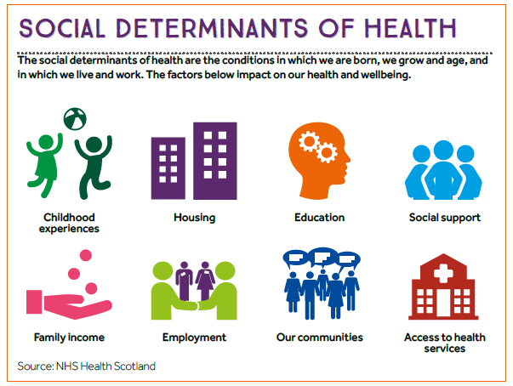
or in more depth, this diagram shows the impact of wider issues on our health, as explained below:
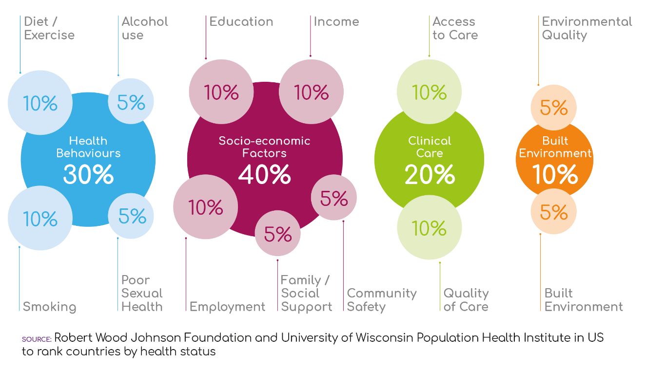
- Our health behaviours including diet, exercise, alcohol, smoking and sexual health contribute 30% to our overall health and well-being
- Our social conditions including education, income, employment, family and social support contribute 40% to our overall health and well-being
- Our clinical care from our Health Services contribute only 20% to our health and well-being
- And the quality of our environment, and our buildings contributes 10%.
Our focus to start with is on Healthy Eating, Physical Activity, Mental Health, Reducing Social Isolation, alongside working with Food Banks, Youth and Schools. We would also like to understand more about provision for those with Special Education Needs and Disabilities (SEND).

HEALTHY EATING
Much is being debated about nutrition these days. ‘You are what you eat’ some say.
Poor nutrition, either insufficient dietary intake or poor quality food can compromise health in a range of ways, such as immunity, mood, body size and shape and many more.
Eating well is the key.
Some agencies will advise the time-honoured low fat, low sugar diets, for example:
Eating a balanced diet that complies with the Eat Well Guide. This will also likely address any micronutrient deficiencies, particularly by eating 5 portions of fruit and vegetables a day (fresh, tinned or frozen), which are rich in vitamins and minerals.
While others will recommend a Low Carb / Keto type diet may be suitable as per this article:
https://www.gov.uk/government/news/a-lower-carb-diet-is-an-effective-short-term-option-for-type-2-diabetes
Whatever your views, Burnham has groups to tap into to help you eat healthily for your body.

PHYSICAL ACTIVITY
Exercise is a key component of Health and Well-being and we are blessed in Burnham with so many opportunities. Our ‘Resources’ list includes many sports clubs, walking groups, yoga, Tai chi and so much more.
Ideally we would like to see more journeys by foot and by bicycle to reduce unnecessary car journeys and to help people get fitter at the same time.
- We want to keep networks of footpaths open and useable across the Dengie
- We want to attract more Bikeability bikeability.org.uk courses to Burnham to help adults, children and families cycle safely.
- We will continue to lobby the Essex County Council and Maldon District Council and any potential partners to build a cycle path between Southminster and Burnham, especially for children to get to schools.
- We will continue to lobby Essex County Council for safer roads with safer speed limits to enable cyclists to enjoy our lovely flat peninsula, ideal for this form of transport.
https://www.activeessex.org/find-your-active/

MENTAL HEALTH
Essex County Council has information about getting mental health support. Find information here
https://www.essex.gov.uk/mental-health/get-help-and-support
Public Health England have launched their new ‘Every Mind Matters Campaign’. For information, support, advice and the ability to develop your own mind plan, please visit:
https://www.nhs.uk/every-mind-matters/
Find out how you can do things for others on: www.actionforhappiness.org. This includes 10 keys to happier living
- Giving – Do things for others
- Relating – connect with people
- Exercising – take care of your body
- Awareness – live life mindfully
- Trying out – keep learning new things
- Direction – have goals to look forward to
- Resilience – find ways to bounce back
- Emotions – look for what’s good
- Acceptance – be comfortable with yourself
- Meaning – be part of something bigger
Mental Health First Aid (MHFA) have launched a My Whole Self toolkit (https://mhfaengland.org/mhfa-centre/news/my-whole-self-toolkit-launch/), the digital centre piece of its new campaign for workplace culture change. The toolkit helps everyone to support their mental health while working from home.
Livewell Essex has also put together 10 ways to well-being,
Living Well in Essex website - Livewell (livewellcampaign.co.uk)

For urgent Mental Health support contact these numbers:
If you've had thoughts of self-harming or are feeling suicidal, contact someone immediately such as your GP, a friend, a relative or someone else you can trust.
- Urgent: call 999
- The Samaritans – call 116 123
- Non-urgent: call your local GP, or NHS on111
- Health in Mind (IAPT) – 01376 308704 for a wide range of talking therapy treatments for adults with common mental health problems. Health in Mind is part of a national initiative and individuals can self-refer online find out more here.or call, or visit your GP
SOCIAL ISOLATION
It is incredibly important to maintain contact with your friends, family and work colleagues to maintain your social connectedness and general well-being. If you would like to join a local group or receive befriending support, please look at the ‘Resource Database’ (Appendix 1) which lists Clubs/Sports etc available in Burnham on Crouch or if you would like help to signpost you to these facilities speak to Cllr Paula Stanbury 07419 379722.
And explore Maldon District CVS website:
https://www.maldoncvs.org.uk/our-projects/
FOOD BANKS
There are wonderful volunteers running the Food Pantry in Southminster. Burnham Town Council are working alongside community leaders to improve access for Burnham residents and extend services where possible
YOUTH
There are many Sports Clubs in our town for local children (see the Resources Database) ranging from the excellent Rugby, Football, Golf, and Sailing Clubs. There are the Sea Scouts, Scouts, Cubs, for example but not so much is organised for the older children in town. The Council is researching what other facilities could be made available to youth through activities organised by ECC, MDC the Churches and other groups
SCHOOLS
Following on from the above the Council is reaching out to all the Schools in Burnham on Crouch to understand the views of pupils, teachers and parents, and their work on Health and Well-being.
USEFUL LINKS
Link to our Burnham Health and Wellbeing Resource Database (See Appendix 1)
Live Well Link Well | Live Well Link Well | Maldon District Council
The Livewell campaign | The Livewell campaign | Maldon District Council
Health and wellbeing services: Concerned about your health? - Essex County Council
Links to Burnham Town Council Website will be via dedicated page to Health and Well-being.
Links to a dedicated Facebook Page and other social media will be created as deemed appropriate.
Our sincere thanks go to residents who have given their time to the working group:- Suzanne Brewer, Lorraine Read, Maggie Kilbride, Pauline Wells, Philippa Wilkin and to all those community leaders who have given their thoughts and ideas to the project so far.

